# ­­­­Brandon Hogue

# IR Transmit Data Sheet

This module takes a signal from the PIC (modulated at 56 kHz) and amplifies the signal through via a constant current configured NPN bipolar junction transistor.

# Schematic:

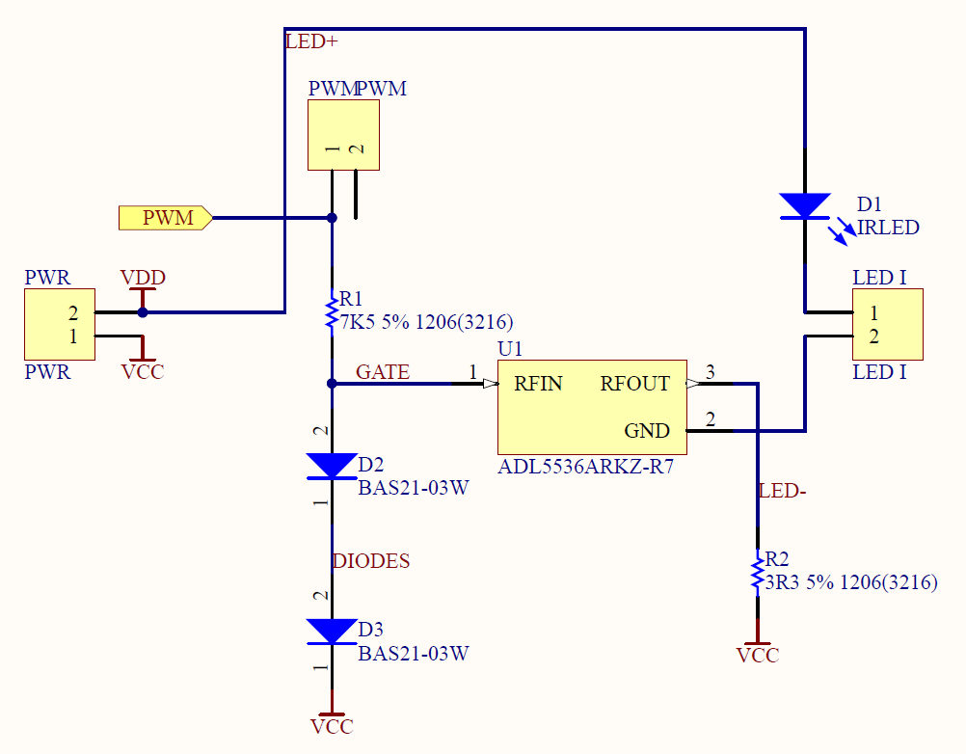

# PCB Layout:

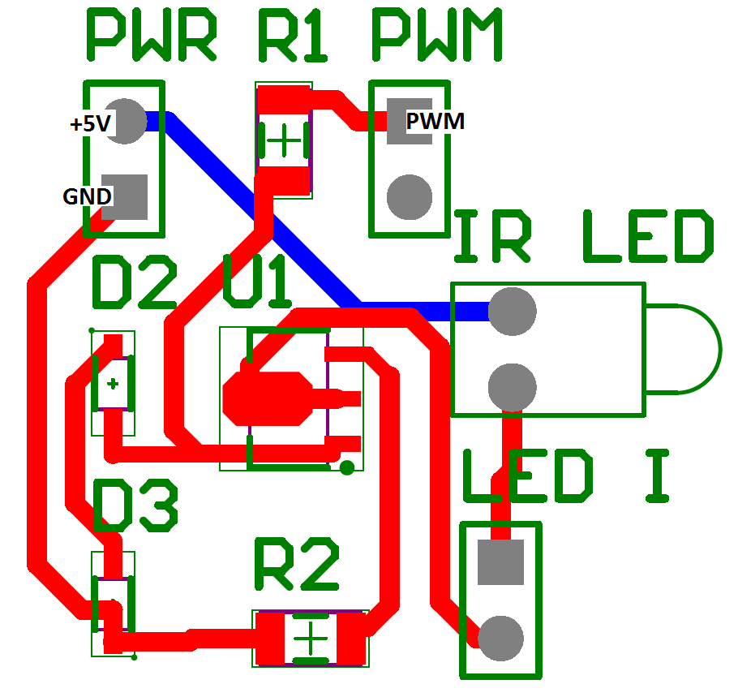

# Hardware Inputs:

|  |  |  |
| --- | --- | --- |
| Input Name | Description of Signal | Expected Range |
| 5V | --- | 120mA |
| GND | --- | --- |
| PWM | 56kHz modulated IR | 0V or 5V |
|  |  |  |

# Software:

|  |  |  |  |
| --- | --- | --- | --- |
| Function Name | Description | Input Parameters | Return Value |
| SendIR | Sends IR data | Packet Type, Count | N/A |

